CS 255 System Design Document Template

UML Diagrams

UML Use Case Diagram
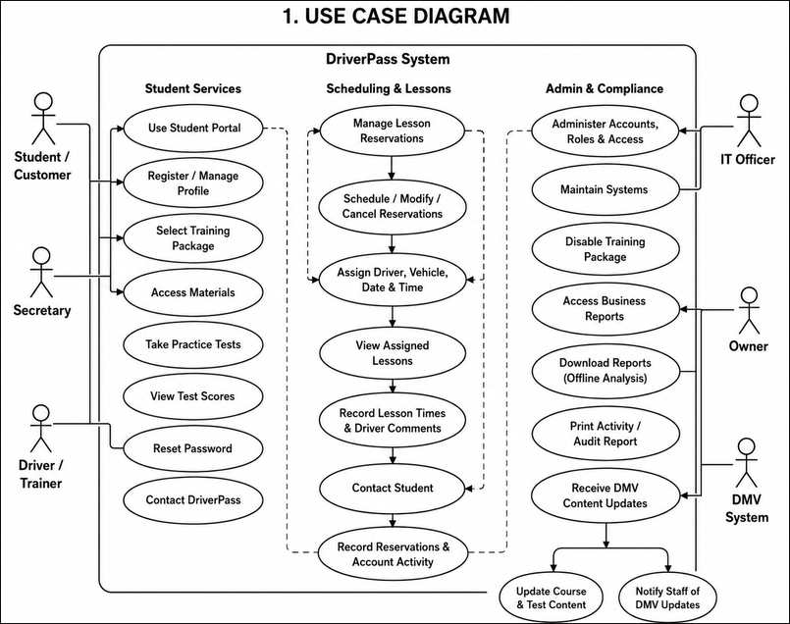

UML Activity Diagrams
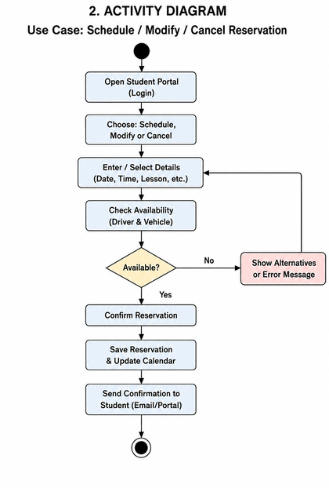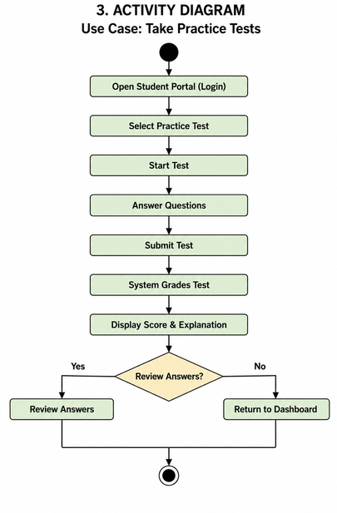

UML Sequence Diagram
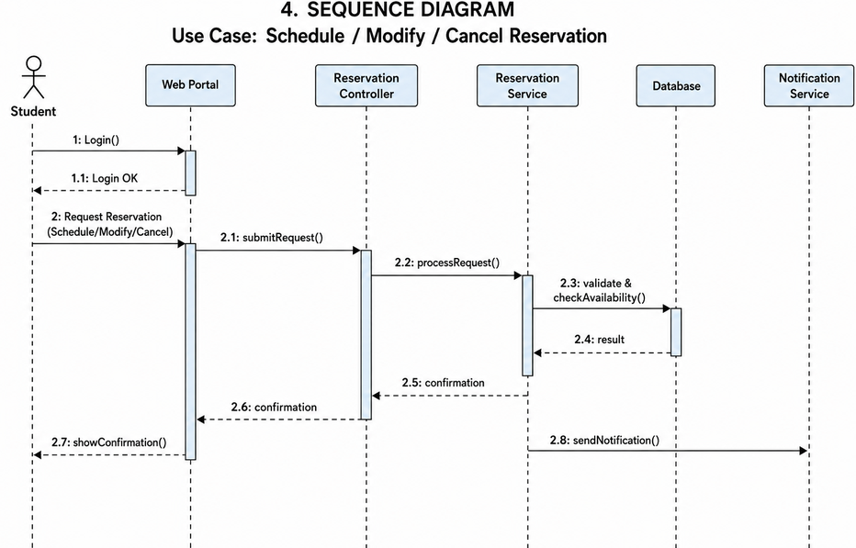

UML Class Diagram
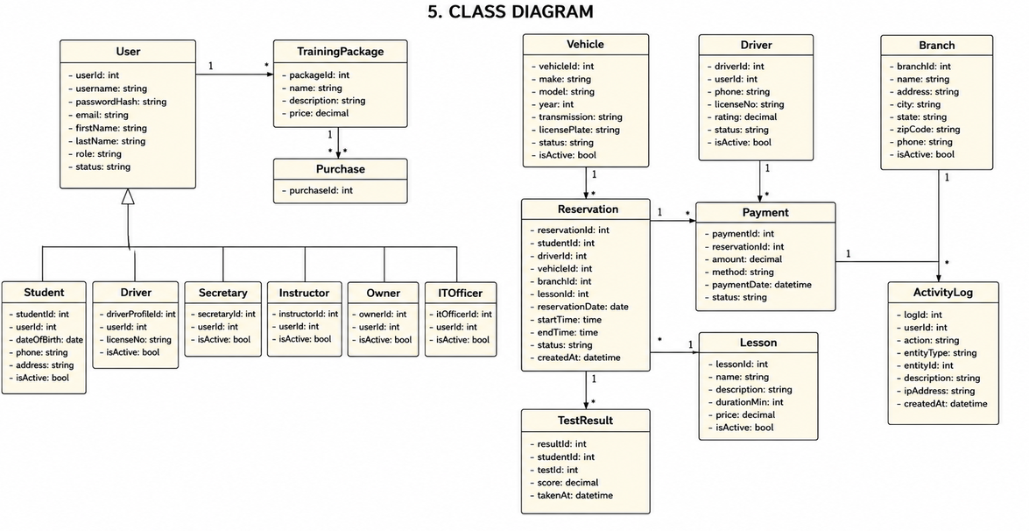

Technical Requirements
- Hardware: DriverPass will require internet-connected desktop or laptop computers for office employees and compatible computers, tablets, or mobile devices for customers accessing the system. Because DriverPass requested a web-based system that can be accessed from different locations and devices, the primary application and database should be hosted through cloud infrastructure rather than relying on an on-site server. The cloud environment must provide sufficient processing, storage, and backup capacity for customer records, reservations, lesson information, test results, training content, and activity records.

- Software: The proposed system will operate as a browser-based web application so customers and employees can access DriverPass without installing specialized software. A server-side application will process user accounts, reservations, training packages, practice tests, reports, and other business functions. A relational database management system will maintain structured information such as student accounts, reservations, drivers, vehicles, lesson records, and test results. The system should also support exporting reports into formats that can be opened with spreadsheet software because DriverPass wants to download information for offline analysis.

- Tools: Development will require an integrated development environment for application development, a database management tool, version-control software for managing changes to the source code, and testing tools for verifying system functionality and security. Lucidchart will serve as the CASE tool for maintaining the UML models used to document the system. Integration tools or an API connection will also be required to receive updated rules, policies, and test information from the DMV.

- Infrastructure: DriverPass should use secure cloud infrastructure capable of supporting remote access, centralized data storage, backups, and recovery. All online communication should use encrypted connections, and access to system functions should be controlled according to each user's role. The infrastructure must also maintain activity records showing significant account and reservation changes. Centralized cloud storage is important because users may access the system from different devices, while updates to DriverPass data should occur through the online system to prevent conflicting or duplicate records. This design supports DriverPass's need for reliable online access while allowing authorized reports to be downloaded for offline review.

